FORNAX™ ePlanCheck Rule
Rule Information
Rule ID | SSW 3.1.3.2 (a)
Rule Name | Inspection Chamber – 50000mm
Chapter | 3. Sanitary Works
Section | 3.1 Sanitary Drainage System
Handbook | Code of Practice on Sewerage and Sanitary Works  Addendum No. 2 – Nov 2004

Rule Description
3.1.3.2 Main Drain-line

(a) The main drain-line shall have a minimum diameter of 150mm and distance between inspection chambers
shall not exceed 50 meters.

Rule Interpretation
- This rule checks for the maximum distance between two Inspection Chambers in a project which is connected by a main drain-line.
- The main drain-lines are defined as the sanitary lines that are connected from inspection chamber to inspection chambers.
- The maximum distance between the Inspection Chambers is 50000mm (50 meters).
- Distance is measured from the center of the Inspection Chamber to the center of the next Inspection Chamber.

INSPECTION
CHAMBER 1
INSPECTION
CHAMBER 2
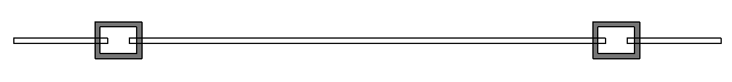
MAIN DRAIN-LINE

MAXIMUM DISTANCE
50000 mm

PLAN

FIGURE 01

Rule Scenario

Scenario 01-Compliant
Requirement | Distance between inspection chambers should not exceed 50 meters.
Conditions | Should be connected to a main drain-line.
Description | Lateral distance from the center line of an inspection chamber to the center line of the next inspection chamber is 50000mm (50 m).
INSPECTION CHAMBER 1
INSPECTION CHAMBER 2
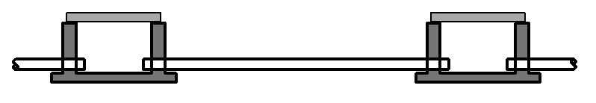

MAIN DRAIN-LINE

50000MM
DISTANCE BETWEEN CHAMBERS

SECTION
FIGURE SCENARIO

Scenario 01-Non-compliant
Requirement | Distance between inspection chambers should not exceed 50 meters.
Conditions | Should be connected to a main drain-line.
Description | Lateral distance from the center line of an inspection chamber to the center line of the next inspection chamber is 57340mm (57.34 m).
INSPECTION CHAMBER 1
INSPECTION CHAMBER 2

MAIN DRAIN-LINE

57340MM
DISTANCE BETWEEN CHAMBERS

SECTION
FIGURE SCENARIO

Scenario 01-Attention
Requirement | Distance between inspection chambers should not exceed 50 meters.
Conditions | Should be connected to a main drain-line.
Description | Lateral distance from the center line of an inspection chamber to the end of the main drain-pipe attached to it. The length of the pipe is not necessary to be shown.
INSPECTION CHAMBER
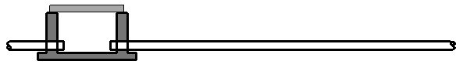

MAIN DRAIN-LINE

SECTION
FIGURE SCENARIO

Model PreCheck

Required Elements | Required Attributes
DistributionChamberElement | Name contains “Inspection Chamber”

Rule Parameters

System Type
Cold Water
Hot Water
 | Sanitary | 
 | Sewerage
Vent

Element Type 1
State | Type | Property | Operator | Value
Include | DistributionChamberElement | Name | Contains | Inspection Chamber
Exclude |  | Any | Match | N.A.
 |  |  | N.A. | <User defined>

Element Type 1 Condition
* Maximum distance in between = | 50000 | mm
* Should be connected by a Main Drain Line

Result Messages
- 3.1.3.2 (a) Distance between Inspection Chambers
  - Non-compliant (TotalResultNumeric)
    - BuildingStorey (TotalResultPerFloorNumeric)
  - ElementType1Name: Distance = ResultValueNumeric mm to ElementType1Name
  - Compliant (TotalResultNumeric)
    - BuildingStorey (TotalResultPerFloorNumeric)
      - ElementType1Name: Distance = ResultValueNumeric mm to ElementType1Name
  - Attention (TotalResultNumeric)
    - BuildingStorey (TotalResultPerFloorNumeric)
      - No inspection chamber to check.
      - Only one inspection chamber found.
      - Inspection Chamber is not connected to main drain-line.

Sample Result Messages
- 3.1.3.2 (a) Distance between Inspection Chambers
  - Non-compliant (1)
    - Level 01 (1)
  - Inspection Chamber 1.01: Distance = 57340mm to Inspection Chamber 1.02
  - Compliant (2)
    - Level 01 (1)
      - Inspection Chamber 1.03: Distance = 37340mm to Inspection Chamber 1.04
      - Inspection Chamber 1.05: Distance = 50000mm to Inspection Chamber 1.06
  - Attention (2)
    - Level 01 (1)
      - No inspection chamber to check.
      - Only one inspection chamber found.
      - Inspection Chamber is not connected to main drain-line.

Sample Result Model Views
- 3.1.3.2 (a) Distance between Inspection Chambers
  - Non-compliant
    - Plan View.
    - Highlight checked element/space.
- Double-arrow dimensions will appear in highlighted color.
    - All other elements are in translucent except checked element/space.
  - Compliant
    - Plan View
    - Highlight checked element/space.
- Double-arrow dimensions will appear in highlighted color.
    - All other elements are in translucent except checked elementspace.

Testing Scenario Notes
- Scenario 01-Compliant
- Level 01
- 3-units of Inspection Chambers are connected by the main drain line pipe within a lot. Distances between inspection chambers are 50000mm and 37340mm respectively, measured from the center of the Inspection Chamber to the center of the next inspection chamber.

- Scenario 01-Non-compliant
- Level 01
- 2-units of Inspection Chambers are connected by the main drain line pipe within a lot. Distance between two inspection chambers is 57340mm, measured from the center of the Inspection Chamber to the center of the next inspection chamber.

- Scenario 01-Attention
- Level 01
- 1-unit of Inspection Chamber is connected to a main drain line pipe that runs (60670mm) long measured from the center of the Inspection Chamber) to the sewer manhole, bearing the public sewer pipe.

Model:
SSW 3132 a-50000 01-C_v4.ifc
SSW 3132 a-50000 01-NC_v4.ifc
SSW 3132 a-50000 01-A_v4.ifc

Modelling Guideline
- Specify Name containing “Inspection Chamber” for relevant DistributionChamberElementType.
- Specify IfcDescription containing “Main Drain Line” for relevant PipeSegmentType.
- Specify IfcDescription containing “Sewer Connection” for relevant PipeSegmentType.
- Specify Name containing “Sewer Manhole” for relevant DistributionChamberElementType.

Specification Log
RA | Alvin Q. Estocapio
Last edit date | 26 July 2018
ePC version
Updates | - V1

Specification Log
RA | Alvin Q. Estocapio
Last edit date | 13 August 2018
ePC version
Updates | - V2-Update rule interpretation and scenarios based on PUB returns.

Specification Log
RA | Alvin Q. Estocapio
Last edit date | 04 September 2018
ePC version
Updates | - V3-Update rule scenarios.

Specification Log
RA | Alvin Q. Estocapio
Last edit date | 13 September 2018
ePC version
Updates | - V4-Update rule interpretation and scenarios based on PUB returns.

